Temperature Sensors
Resistance Temperature Detectors (RTDs)
Thermistors
IC Temperature Sensors

Drew Gilliam
GE/MfgE 330: Introduction to Mechatronics
03.19.2003

Introduction
There are a wide variety of temperature sensors on the market today, including Thermocouples, Resistance Temperature Detectors (RTDs), Thermistors, Infrared, and Semiconductor Sensors. This paper will discuss three of these alternatives: the RTD, thermistor, and semiconductor sensors.

As we are biased toward an application which can be integrated into the Mechatronics DSP, we will end the discussion with a specific semiconductor sensor, the LM75 offered by National Semiconductor (http://www.national.com/pf/LM/LM75.html). The LM75 has a variety of features, primarily the I2C serial interface, which would allow easy integration in the robot system.

For good descriptions of the sensors:

[1] National Semiconductor
National Temperature Sensor Handbook
http://luna.et-inf.fho-emden.de/datenblaetter/sensor/temphb.pdf

[2] Watlow Electric Manufacturing Company
Temperature Sensors, Educational Series Book 4, 1995
http://www.watlow.com/literature/prodtechinfo/files/sensors/we4e_16.pdf

[3] Analog Devices, Walt Kester
Temperature Sensors
http://www.analog.com/UploadedFiles/Associated_Docs/245380809Power_sect6.pdf

[4] National Instruments
Temperature Sensor Vendors and Tutorials
http://www.ni.com/devzone/advisors/temperature.htm

Resistance Temperature Detector (RTD)
The RTD is a temperature sensing device whose resistance changes with temperature. Typically built from platinum, though devices made from nickel or copper are not uncommon, RTDs can take many different shapes (figure 1). To measure the resistance across an RTD, apply a constant current, measure the resulting voltage, and determine the RTD resistance. We then use a resistance vs. temperature plot to determine the temperature of the surrounding medium (figure 2). RTDs exhibit fairly linear resistance to temperature curves over their operating regions, and any nonlinearities are highly predictable and repeatable.

Figure 1
RTD element styles [2, p.17]
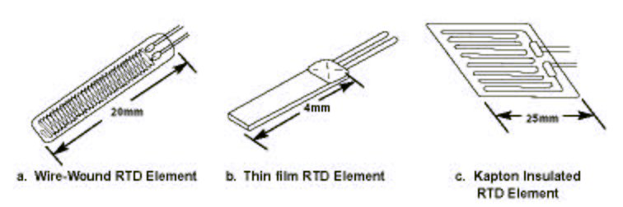

Figure 2
RTD Resistance vs. Temperature
upper curve is straight line reference [1, p.6]
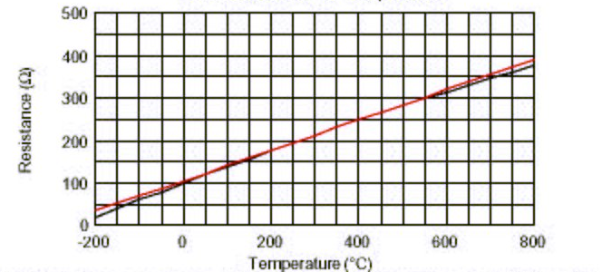

The RTD requires external current excitation, as well as signal conditioning to account for lead wire effects and self-heating. Analog Devices supplies the ADT70, which provides both excitation and signal conditioning for a platinum RTD. The output of this device (5 mv/°C) is be fed through an analog to digital converter, to be converted by the DSP to temperature readings. Figure 3 on the next page supplies two circuit diagrams from the Analog Devices literature. For more information on the ADT70, see http://www.analog.com/Analog_Root/productPage/productHome/0%2C2121%2CADT70%2C00.html

RTD devices are available from numerous suppliers. To find suppliers who fit your needs, I suggest going to the Temperature Sensor listings from Sensors EZ Search (http://www.sensors-ez.com/sensors/0041546_0041557_1.html). While sensitive and accurate platinum sensors can be quite costly, more inexpensive sensors are available that would suit our applications.

Figure 3
ADC conversion, ADT70 [3, p.15]

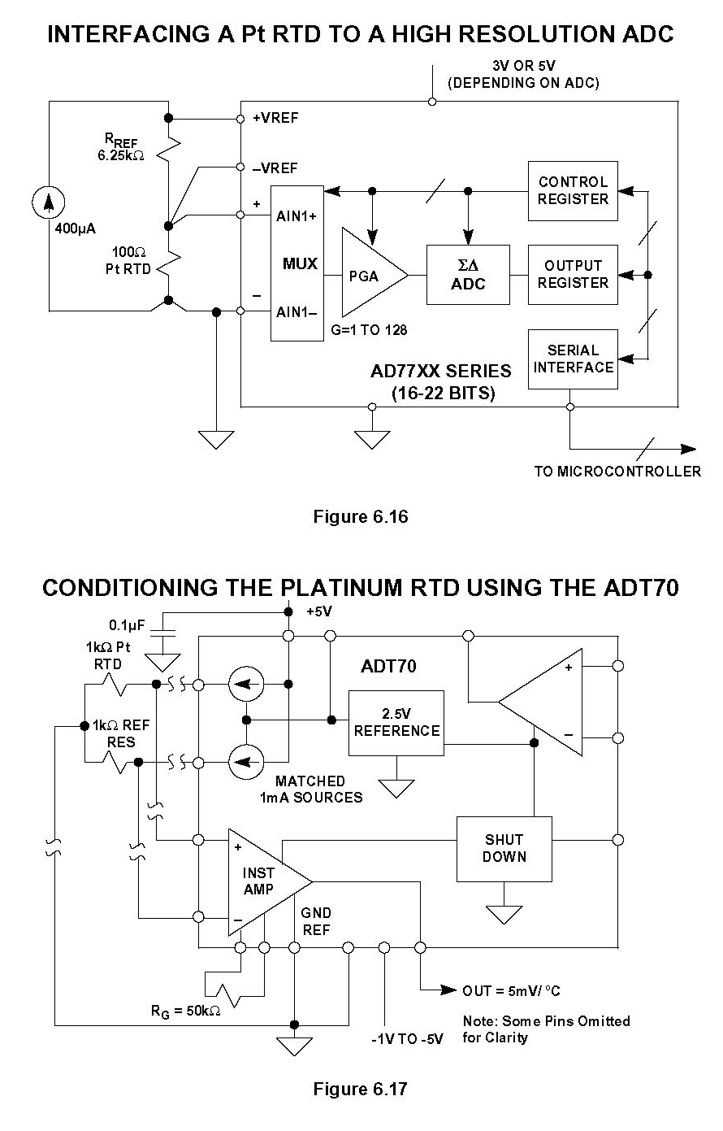

Thermistor
Similar to the RTD, the thermistor is a temperature sensing device whose resistance changes with temperature. Thermistors, however, are made from semiconductor materials (figure 4). Resistance is determined in the same manner as the RTD, but thermistors exhibit a highly nonlinear resistance vs. temperature curve (figure 5). Thus, in the thermistor’s operating range we can see a large resistance change for a very small temperature change. This makes for a highly sensitive device, ideal for set-point applications.

Figure 4
Thermistor element styles [2, p.24]
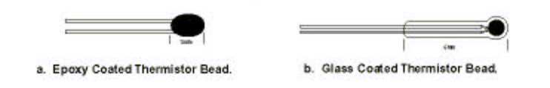

Figure 5
Thermistor Resistance vs. Temperature [1, p.8]

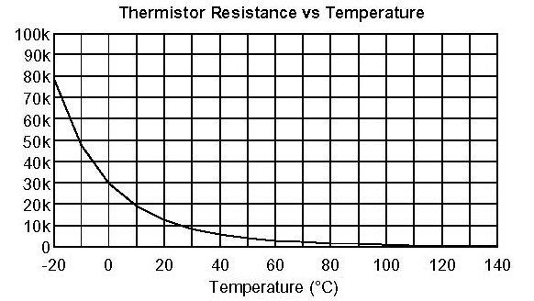

Like the RTD, thermistors require external current excitation and significant signal conditioning. Chips do exist that will convert a thermistor value directly to digital data (MAX6682, Maxim / Dallas Semiconductor - http://www.maxim-ic.com/quick_view2.cfm/qv_pk/3319), but I was unable to find a chip with the I2C serial interface. Simple circuits can be built to read in the thermistor voltage, which can be fed to an ADC, and the temperature determined digitally.

Thermistor devices are available from numerous suppliers. Again, to find suppliers who fit your needs, I suggest going to the Temperature Sensor listings from Sensors EZ Search (http://www.sensors-ez.com/sensors/0041546_0041557_1.html).

IC Temperature Sensors
RTDs and thermistors may be simple devices, but they are likely not suited to any mechatronics application. We need to buy the sensor, purchase a chip or create our own circuitry to apply a constant current and measure the resulting voltage, and run this output through and ADC. All these components need to be matched, for example the ADC needs to have high enough resolution to take advantage of the 5mv/°C change from the ADT70. This can end up being quite complicated and costly.

Chips with temperature sensors built into the integrated circuit may be a better alternative. IC temperature sensors employ the principle that a bipolar junction transistor’s (BJT) base-emitter voltage to collector current varies with temperature:
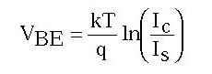
The Bandgap temperature sensor is an example of circuit utilizing this principle (figure 6). Tuning the resistor values R1 & R2 and the number of BJTs N results in a direct relationship between VPTAT and temperature:
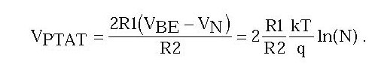

Figure 6 Classic Bandgap Temperature Sensor [3, p.21]

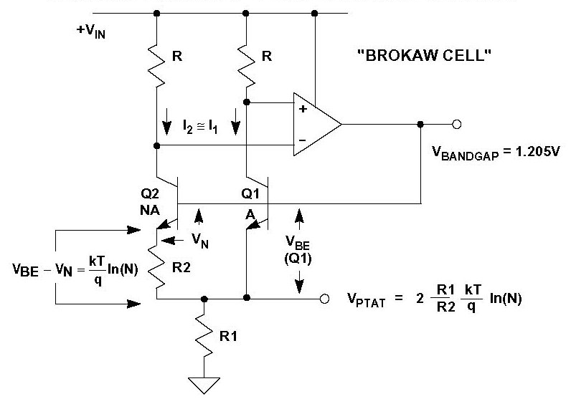

As the temperature sensor is built into the integrated circuit, manufacturers can do all the design for us. Signal conditioning, linearization, and analog to digital conversion can all be done on chip. One such chip, the LM75 from National Semiconductor (http://www.national.com/pf/LM/LM75.html), may suit our application.

Because the LM75 leads are the dominant thermal path, the chip actually measures the board temperature. As long as the board is at the same temperature as the surrounding air, we are in luck. If it is not, we have several alternatives:
- Apply a clip on heat sink to the chip to allow more heat transfer to the air
- Thermally isolate the board on a sub-board connected with long leads.
For more information, National Semiconductor suggests the following article
Steele, Jerry. “Get Maximum Accuracy from Temperature Sensors”
Electronic Design, August 19, 1996.

LM75 Features:
- -55 to +125°C operating range
- ±3°C accuracy (higher accuracy: available in the LM76 & LM77)
- 0.5° resolution (higher resolution: available in the LM76 & LM77)
- I²C Bus interface
- SOP-8 and Mini SOP-8 (MSOP) packages save space
- Open-drain output pin operates as interrupt or comparator/thermostat output
- Register readback capability
- Power up defaults permit stand-alone operation as thermostat
- Shutdown mode to minimize power consumption
- Up to 8 LM75s can be connected to a single bus
- ~$1.00 each (available in rail of 95)
- Readable at any time (new temp. conversion available every 100ms)

Specifications for the LM75 can be found at:
http://www.national.com/ds/LM/LM75.pdf
Example code is available at:
http://www.national.com/an/AN/AN-1155.pdf

Figure 7 LM75 Simplified Block Diagram



