ME 461 Laboratory #7 (2 Week Lab)
Balancing and Steering Control of the Segbot

Goals
- Organize your code from previous labs so that all sensor feedback is sampled in order and the most current signals from the sensors are used in the control law equations.
- Double check the polarity of feedback signals and motor command output so it matches the model assumptions.
- Implement Balance Control of the Segbot. Manually tune offsets and balance gains.
- Implement a driving and steering control for the Segbot.

Exercise 1
Start your Lab 7 code with your Lab 6 code. But note, you will not be using a CPU Timer Interrupt function for this code. You will need to move much of the code you wrote in the CPU Timer Interrupt function into other interrupt functions specified below.
I would like you to organize your code in the following structure by completing these steps. If I forgot a step or code you think is necessary, ask me before adding it.
- Since Lab 6 merged all your Lab 5 code, your Lab 7 code is already sampling the IMU, MPU-9250, every 1 millisecond. You will see below that we will move the start of this SPI transmission from a CPU Timer to ADCA’s interrupt service routine. You will need to copy initializations performed in Lab 4’s main() function that initialized ADCA. You will be using EPWM5 to trigger ADCA channels 2 and 3 (joystick) every 1 millisecond. Also make sure the ADCA interrupt function has been enabled and setup in the PIEVector Table.
- Your Lab 6 code that you started with, should have the setEPWM2A() and setEPWM2B() functions and the initializations for EPWM2.
- Your Lab 6 code should have also called in main() your setupSPIB() function to initialize SPIB and its pins. Make sure the SPIB interrupt function has been enabled and setup in the PIEVector Table.
- Once all the initializations are finished, these next steps will start coding the order the different feedback signals are sampled. You have already setup ADCA channels 2 and 3 to be triggered by EPWM5 every 1ms. So, once you have enabled these interrupts in main(), the code will start the sequence of sampling the needed feedback signals. First in the sequence is sampling ADCA A2 and A3, which are connected to the joystick. Once ADCA A2 and A3 have finished converting, the ADCA_ISR() function is called. Inside the ADCA1 interrupt, make sure to read the joystick results and convert the 12-bit ADC values to voltages. Store the two voltages in global float variables for possible use in the control algorithms implemented in later exercises.
- Still inside the ADCA_ISR() function, after you have read the conversion results of each joystick axis, start the SPI transmission and reception of the three accelerometer readings and the 3 gyro readings of the MPU-9250. This is identical code that you performed in a CPU Timer Interrupt function in Lab 5 and 6. Make sure to only start the SPIB transmission here in the ADC interrupt function and not in the CPU Timer Interrupt function where your lab 5 and 6 code started the SPIB transmission. After the correct 16-bit words have been written to SPITXBUF, the ADC_ISR() function can exit.
- When the SPI is finished transmitting (which also means it is done receiving), the SPIB_ISR() interrupt function will be called by the hardware. Inside the SPIB_ISR() interrupt function, pull the MPU-9250’s Slave Select high and read the 6 IMU values. So that your code works with the next exercises given code, call your three accelerometer and gyro readings float accelx, float accely, float accelz, float gyrox, float gyroy, and float gyroz. Just like in Lab 5 and Lab 6 (so this should already be done), convert to units of g for the accelerations and units of degrees/s for the gyro rates.
- Still inside the SPIB interrupt function, call the readEncLeft() and readEncRight() functions to sense the left and right motor’s angle. Note that you should have called the eQEP initialization function in main() to setup the eQEP. Store motor angles in two global variables. Finally set UARTPrint equal to 1 every 200 times into the SPIB interrupt so that the while(1) loop in main() is told to print every 200 ms. Set the serial_printf() function in main()’s while(1) loop to print the joystick voltages, the accelerometer z value, the gyro x value and both motor angles.
- The Segbot balance controller will run every 4ms but we will take care of that in the next section. For this section simply make sure that the polarities of your motor feedback and controller output are the same as the below figure. (This is the same polarities that we set for Lab 6, but let’s check to be sure). You will need to add calls to your setEPWM2A() and setEPWM2B() functions inside the SPIB interrupt function so that you can drive the motors open-loop as you did initially in Lab 6. Create, if not already created, global float uLeft and uRight variables and simply pass them to the correct setEPWM2X() functions. Add negatives where necessary to set the correct direction of the feedback and output commands. Remember the best place to add a negative for the output is on the “u” value passed to the setEPWM2X() functions. For example: setEPWM(-u);.
Show Your TA your working code and correct polarities. Also note that GyroX has the correct positive direction as the below figure, but AccelZ is in the opposite direction. We will take care of that negative in the Kalman Filter code in Exercise 2.
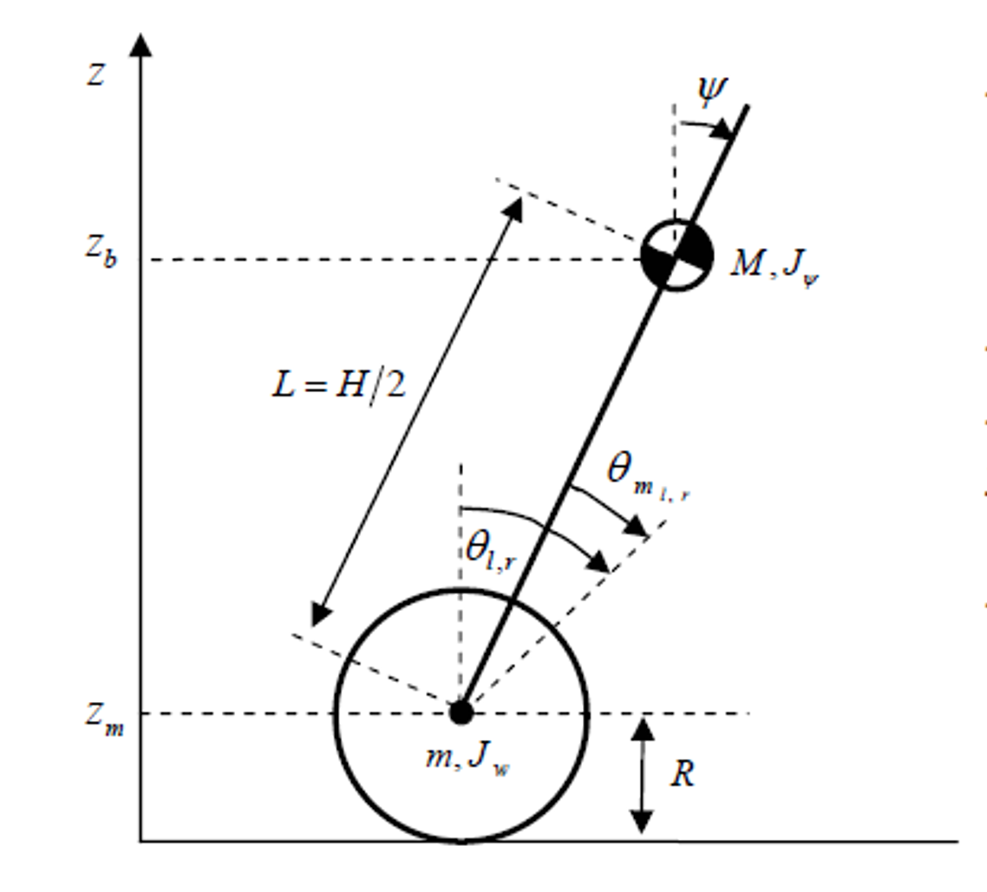

Exercise 2
Now that you have your program sampling all needed feedback signals every 1ms and the direction of the feedback and motor torque commands are correct, you are ready to implement the balance control for the Segbot. But first, a very important piece of the control algorithm for balancing the Segbot is using the Kalman filter equations. These perform sensor fusion of the integral of the rate gyro and the accelerometer tilt value to produce a responsive tilt measurement. The accelerometer gives us a tilt measurement, but the responsiveness of this tilt measurement is slow. The integral of the rate gyro, which also gives tilt angle, is a very responsive feedback. But, it has the problem that it drifts over time due to signal noise.
Using the Kalman filter, the accuracy of the accelerometer and the responsiveness of the integral of the gyro are fused together to produce a tilt measurement that is responsive and does not drift. I will be covering the Kalman filter in future lectures so for now I am giving you the code that performs the Kalman Filter equations. See the code below. This code should be copied into your SPIB_ISR() function.
- First, copy all the given global variables towards the top of your main file where the rest of your global variables are defined.
- Copy this code and paste it in your SPIB interrupt function right after your code has read the IMU values and scaled them to their correct units. Look through this given code to see if you are already doing some these steps and comment out your code if anything is redundant. I am mainly thinking here about the last few lines of this given code that blinks LEDs, triggers an UART print and acknowledges the SPIB interrupt.
Before you go onto writing the controller code to balance the Segbot let’s go through the given code.
- For the first four seconds, the code is calculating the constant offsets of the three accelerometers and the three rate gyros. Actually, the first 2 seconds the code is doing nothing in order to let the IMU settle down after power on. Then for the next 2 seconds, the code is summing up each reading received. At the end of those 2 seconds the summed variable is divided by 2000 to find the average offset over a 2 second span.
- After the 4 seconds have elapsed the offsets have been found and calibration_state is set to 2 which means the offset calibration is complete and the balance algorithm can run.
- Now every 1 ms the Kalman filter equations are run to calculate the kalman_tilt value.
- The balancing control law works well at 4 ms. However, the Kalman equations are run every 1 ms, a 4-point average is performed to filter the feedback signals a bit more. A 4-point average is also performed on the left and right encoder position values.
- Finally the Software Interrupt function, SWI_isr() is triggered to run. You will write all the remaining Segbot balancing C code in this function. Change your serial_printf() to print the four 4-point averaged feedback signals to Tera Term every 200 ms, tilt_value, gyro_value, LeftWheel, RightWheel.
// Needed global Variables
float accelx_offset = 0;
float accely_offset = 0;
float accelz_offset = 0;
float gyrox_offset = 0;
float gyroy_offset = 0;
float gyroz_offset = 0;
float accelzBalancePoint = -.76;
int16 IMU_data[9];
uint16_t temp=0;
int16_t doneCal = 0;
float tilt_value = 0;
float tilt_array[4] = {0, 0, 0, 0};
float gyro_value = 0;
float gyro_array[4] = {0, 0, 0, 0};
float LeftWheel = 0;
float RightWheel = 0;
float LeftWheelArray[4] = {0,0,0,0};
float RightWheelArray[4] = {0,0,0,0};
// Kalman Filter vars
float T = 0.001; //sample rate, 1ms
float Q = 0.01; // made global to enable changing in runtime
float R = 25000;//50000;
float kalman_tilt = 0;
float kalman_P = 22.365;
int16_t SpibNumCalls = -1;
float pred_P = 0;
float kalman_K = 0;
int32_t timecount = 0;
int16_t calibration_state = 0;
int32_t calibration_count = 0;

//Code to be copied into SPIB_ISR interrupt function after the IMU measurements have been collected.
if(calibration_state == 0){
calibration_count++;
if (calibration_count == 2000) {
calibration_state = 1;
calibration_count = 0;
}
} else if(calibration_state == 1) {
accelx_offset+=accelx;
accely_offset+=accely;
accelz_offset+=accelz;
gyrox_offset+=gyrox;
gyroy_offset+=gyroy;
gyroz_offset+=gyroz;
calibration_count++;
if (calibration_count == 2000) {
calibration_state = 2;
accelx_offset/=2000.0;
accely_offset/=2000.0;
accelz_offset/=2000.0;
gyrox_offset/=2000.0;
gyroy_offset/=2000.0;
gyroz_offset/=2000.0;
calibration_count = 0;
doneCal = 1;
}
} else if(calibration_state == 2) {
accelx -=(accelx_offset);
accely -=(accely_offset);
accelz -=(accelz_offset-accelzBalancePoint);
gyrox -= gyrox_offset;
gyroy -= gyroy_offset;
gyroz -= gyroz_offset;

/*--------------Kalman Filtering code start---------------------------------------------------------------------*/
float tiltrate = (gyrox*PI)/180.0; // rad/s
float pred_tilt, z, y, S;

// Prediction Step
pred_tilt = kalman_tilt + T*tiltrate;
pred_P = kalman_P + Q;

// Update Step
z = -accelz; // Note the negative here due to the polarity of AccelZ
y = z - pred_tilt;
S = pred_P + R;
kalman_K = pred_P/S;
kalman_tilt = pred_tilt + kalman_K*y;
kalman_P = (1 - kalman_K)*pred_P;

SpibNumCalls++;
// Kalman Filter used
tilt_array[SpibNumCalls] = kalman_tilt;
gyro_array[SpibNumCalls] = tiltrate;
LeftWheelArray[SpibNumCalls] = readEncLeft();
RightWheelArray[SpibNumCalls] = readEncRight();

if (SpibNumCalls >= 3) { // should never be greater than 3
tilt_value = (tilt_array[0] + tilt_array[1] + tilt_array[2] + tilt_array[3])/4.0;
gyro_value = (gyro_array[0] + gyro_array[1] + gyro_array[2] + gyro_array[3])/4.0;
LeftWheel=(LeftWheelArray[0]+LeftWheelArray[1]+LeftWheelArray[2]+LeftWheelArray[3])/4.0;
RightWheel=(RightWheelArray[0]+RightWheelArray[1]+RightWheelArray[2]+RightWheelArray[3])/4.0;
SpibNumCalls = -1;

PieCtrlRegs.PIEIFR12.bit.INTx9 = 1; // Manually cause the interrupt for the SWI
}
}

timecount++;

if((timecount%200) == 0) {
if(doneCal == 0) {
GpioDataRegs.GPATOGGLE.bit.GPIO31 = 1; // Blink Blue LED while calibrating
}
GpioDataRegs.GPBTOGGLE.bit.GPIO34 = 1; // Always Block Red LED
UARTPrint = 1; // Tell While loop to print
}

SpibRegs.SPIFFRX.bit.RXFFOVFCLR=1; // Clear Overflow flag
SpibRegs.SPIFFRX.bit.RXFFINTCLR=1; // Clear Interrupt flag
PieCtrlRegs.PIEACK.all = PIEACK_GROUP6;

Exercise 3: Balance Segbot
At this point in the flow of the code, you enter the software interrupt function SWI_isr(). Inside the SWI you have all the feedback data collected that you need to implement and run the balancing control law for the Segbot.
- First, calculate left and right wheel speed in radians/second. As discussed in lecture use the continuous transfer function ${125s}/{(s+125})$ to estimate these velocities. Remember that this continuous transfer function becomes the discrete transfer function $({100z-100)}/{(z-0.6)}$ at 0.004 seconds. Find the difference equation for this transfer function. With this difference equation, solve for a filtered version of float vel_Right and float vel_Left.
- Also with the same exact derivative approximation, $({100z-100)}/{(z-0.6)}$ at 0.004, find the derivative of the gyrorate value and call it gyrorate_dot.
- Now you have all the states needed to calculate your balancing control. The full state feedback controller equation is: $u= -kx$. In this case the states are $x_{1}$ = tilt, $x_{2}$ = gyrorate, $x_{3}$ is the average of the left and right motor velocities in radians/second, and $x_{4}$ = gyrorate_dot. Calculate this control law and assign it to the variable ubal.
- $ubal= -K_{1}*\text{tilt}-K_{2}*\text{gyrorate}-K_{3}(\text{velLeft}+\text{velRight})/2.0-K_{4}*\text{gyrorate_dot};$
- Use $K_{1}=-60$, $K_{2}=-4.5$, $K_{3}=-1.1$, and $K_{4}=-0.1$ .
- ubal is the control effort for both motors, so set uLeft = ubal/2 and uRight = ubal/2;
- Write these values to the setEPWM2X() functions to drive the motors.
- Have your TA explain the initialization procedure for the Segbot. You will need to start the Segbot on its kickstands and then switch on the amp switch. Keep the Segbot at rest for the first four seconds so it can calculate the IMU offsets.
- Demo your Segbot balancing. Once you have balancing working power your Segbot with a battery. You will probably notice the Segbot either drifting forward or backward. Adjust the variable accelzBalancePoint in a CCS Watch Expression until you improve this drift. It will not be perfect. We will fix this drift even better in Exercise 5. Change accelzBalancePoint to the value you found in your code.

Exercise 4: Steering the Segbot
When playing with your Segbot in exercise 3 after getting it to balance, you may have noticed the Segbot drifting to the left or to the right. If it was not drifting, you probably noticed that it was pretty easy to turn the Sebot left or right. The reason for this is that in exercise 3 only the balance control was implemented. The balance control is not watching the bearing angle of the Segbot, only the velocity of the motors. In this exercise you will implement a PID control algorithm to command the Segbot to an angle and to a given turn rate. This will allow you to steer the Segbot just as you did the robot car in Lab 6.
When designing a control law to steer the Segbot, we have to keep in mind that the most important part of the controller is the balancing controller. If the turn command to the Segbot overpowers the balance control, the Segbot will fall over. Remember that the limit of the control effort, uLeft and uRight, is -10 to +10. To keep the turn control command from overpowering the balance control, the turn command will be limited between -4 to +4. It is possible to change this if you need faster turns but some limit is necessary otherwise the balance control will not be able to do its job.
The control law that is explained below attempts to control the difference between the Segbot’s left and right wheel angles. If the difference between the wheel angles is commanded to stay at zero then the Segbot will not turn. When the Segbot is turning one wheel is turning more than the other, or if the Segbot is turning in place one wheel is turning positive and the other wheel is turning negative. This control law is assuming minimal wheel slippage, which is usually a good assumption.
Use the below block diagram and bullet items to implement the steering control. Make sure to note the positive and negatives in the summer blocks.
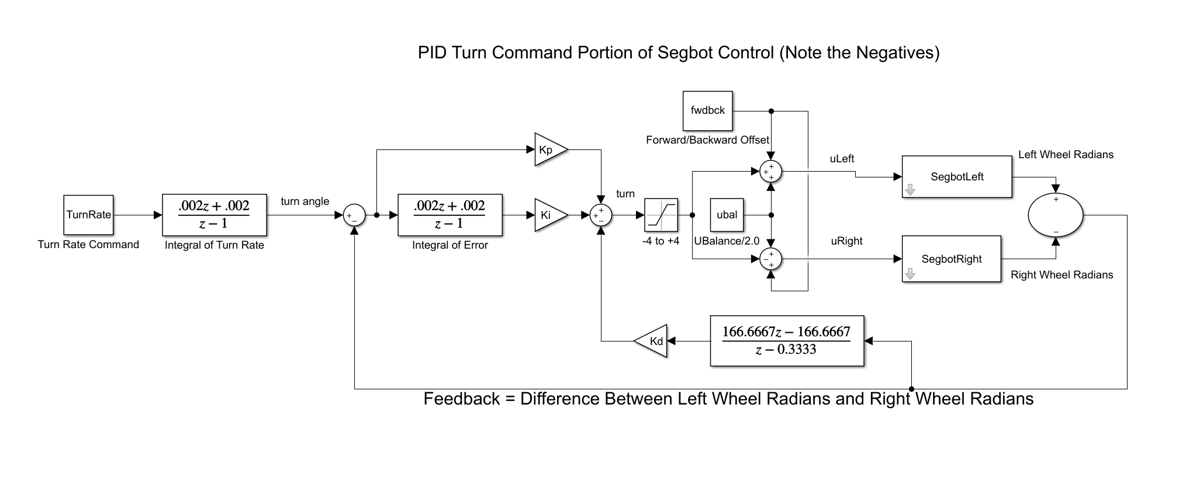
Think of this control initially as separate from the balancing control. The last step will be to saturate the control and add it to the left wheel’s balance control and subtract it from the right wheel’s balance control.
- Create a global float variable WhlDiff and set it equal to the difference between the left wheel’s angle in radians and the right wheel’s angle in radians. (Note if you do not like the variable names I suggest below, you can use your own naming convention).
- Find the rate of change (velocity) of this WhlDiff feedback by performing similar filter equations as done in exercise 3 but here using the filter $250s/(s+250)$ which in discrete time is $(166.667z-166.667)/(z-0.333)$ at 0.004 second sample period. You will need to form the difference equations of this discrete filter. Remember to create variables WhlDiff_1 (old value), vel_WhlDiff, and vel_WhlDiff_1 (old value).
- Create a float variable turnref. In the block diagram above it is labelled “turn angle.” By changing this turnref variable, you will be able to command the Segbot to turn to an angle and stop. Note that turnref is not directly the angle the robot will turn to. You would have to take into account the wheel’s diameter and the distance between the wheels for that to be accomplished. You will see in later steps that for steering around the Segbot it is better to command a turn rate, so we will not take time to calibrate the turnref to an actual angle of the Segbot.
- Create an error variable and find the error between turnref and your feedback signal WhlDiff. So, errorDiff = turnref-WhlDiff;.
- Similar to what you did in Lab 6, integrate errorDiff using the trapezoidal rule. You will have to create an error old variable and an integral old variable.
- Calculate your PID control to give you the turn command.
- turn = Kp*errorDiff + Ki*intDiff - Kd*vel_WhlDiff;
- Guard against integral windup by checking if the absolute value, fabs(), of turn is greater than 3. If it is then set intDiff to the old intDiff variable.
- Saturate turn between -4 and 4.
- Save the current values to the “old” variables, errorDiff_1, vel_WhlDiff_1, intDiff_1.
- Now you are ready in calculate the control effort for the left and right wheel. Calculate your uLeft and uRight. Notice that turn is subtracted from uRight and added to uLeft.
uRight = ubal/2.0 - turn;
uLeft = ubal/2.0 + turn;

- Start out with Kp = 3.0, Ki = 20.0, Kd = 0.08.
- Build and run your code. When running and balancing, in a Code Composer watch expression, change the value of turnref to 1 or even a larger number to see your Segbot turn. Then set turnref to a negative number and your Segbot should turn the other way. To see the effects of poorly tuned PID gains, change to Kp = 1.0, Ki = 20.0, Kd = 0.01. Again, change turnref positive and then negative to apply step changes in the Segbot’s turn. How does the Segbot react with these poorly tuned gains? Show your TA, then put the PID gains back to the first set. For your final project, you may want to tune these PID gains to get the Segbot to respond to turn commands with a different response, faster of slower depending on your application.
- To steer the Segbot around the room, it is easier to command a turn rate instead of a turn angle. There may be some situations where commanding an angle is better. For example, to have the Segbot dance, it may be nice to command an angle. The reference to this PID control is the turnref or an angle. To change to commanding a turn rate, you will add another integral equation to integrate the turn rate command to solve for turnref (see block diagram above).
- Create a float variable turnrate along with an old turnrate_1, and an old turnref_1. Use again the trapezoidal rule to integrate turnrate to give you the turnref needed each 4ms in your PID control equations.
- Build, run, and test your code. In a CCS Watch Expression, set turnrate to a small value and see that your Segbot turns at a certain rate.

Exercise 5
For this Segbot speed controller, I am giving you a bit less detail on how to implement this final part of the controller in order to have you think through the PI controller implementation yourself. This speed control will add one additional control effort to our uRight and uLeft equation. The final equation for uRight and uLeft will be as follows:
uRight = ubal/2.0 – turn - ForwardBackwardCommand;
uLeft = ubal/2.0 + turn - ForwardBackwardCommand;
Note: the negative sign is due to how the Segbot directions have been defined.
Use these bullet points to guide you in implementing this speed control of the Segbot.
- The feedback for this speed control will be the average wheel velocity (velLeft + velRight)/2.0. Error will be eSpeed = (Segbot_refSpeed - (velLeft + velRight)/2.0).
- Implement a PI control using this error and starting with KpSpeed = 0.35 and KiSpeed = 1.5:
ForwardBackwardCommand = KpSpeed*eSpeed + KiSpeed*IK_eSpeed;
- Saturate IK_eSpeed at its current value if fabs(ForwardBackwardCommand) > 3.
- Saturate ForwardBackwardCommand to not be less than -4 and not greater than 4.
Once you have implemented this last feedback loop for the Segbot controller, download and run your code. With Segbot_refSpeed = 0, you should find that the Segbot does a better holding itself at zero speed. It still moves a bit to stay balanced, but it should stay in place better.
With the controller fully working, setup your code to communicate with LabVIEW. Your timer interrupt function from Lab 6 should have the Lab 6 code for communicating with LabVIEW. Move that code into the software interrupt SWI_isr() function. Change the numTimer?Calls count variable to the numSWIcalls count variable used in the SWI. Copy over your kinematic equations that calculate the $x$, $y$, and bearing ($θ)$ pose of the Segbot (these are the same equations for both the Lab 6 Robot configuration and the Segbot configuration). Also, change the two lines of code that when NewLVData is equal to one. Assign Segbot_refSpeed to fromLVvalues[0] and turnrate to fromLVvalues[1].
Remind yourself of the steps given in Homework #2 and Lab #6 to connect LabVIEW with your robot. Then, put your Segbot on the floor and first get the Segbot balancing. Then, telnet into your robot’s ESP32, run tcpLVCOM, run your LabVIEW program, and start steering the Segbot around the floor. To command the Segbot to go backwards you will need to add a case in your LabVIEW program for when the ‘s’ key is pressed. If the ‘s’ key is pressed subtract 0.1 from Vref.

Lab Checkoff
- Demonstrate your “Merged” code working. Sampling the joystick, IMU, optical encoders and commanding PWM.
- Demonstrate the Kalman filter code working.
- Demonstrate your Segbot Balancing.
- Demonstrate the turn PID code working with good PID gains and poor PID gains.
- Demonstrate the Segbot running on the floor commanding it forward and backwards and turning left and right.
- Submit all your written code after adding comments explaining what you learned. Also be clear what code is for what exercise.
- Submit your HowTo document with things to remember about working with the Segbot. In addition, answer these questions:
  - Discuss why the Kalman filter is needed in balancing the Segbot. You do not need to get into the details of the Kalman filter. Think of one other system, and list its feedback signals that may also require the use of the Kalman filter algorithm.
  - To control the Segbot, we implemented two controller algorithms. The first, u = -Kx, stabilizes the Segbot. The second is a PID controller that takes wheel difference as the input, turn = PID (wheel difference). Explain with code and discussion paragraphs what the PID (wheel difference) is accomplishing. Make sure to also comment on why we saturated this turn control value to +/- 4.

