ME 461 LabVIEW #4
Due November 10th 2:00 PM

Introduction
For this exercise, I would like you to first reproduce the VI shown in exercise 1. Then, in exercise 2 and 3, create a similar VI that performs the same function as the first using different methods. Exercise 1 utilizes an “if-else” condition, exercise 2 uses a SubVI, and exercise 3 implements the same function in the form of a Formula Node.
Again, for this this LabVIEW start out by creating a LabVIEW Project. Then inside this project, add a single VI. We are using a project this time so that the SubVI you will be creating will be saved in your project. I will give some pointers and instructions below, but you will need to do a bit of your own hunting to find the necessary blocks and other parts of the program and use LabVIEW help to figure out how to use/wire certain blocks. Many of the blocks I used below come from the “Control Design & Simulation Simulation” section of LabVIEW.
Note: There are a lot of small blocks in the LabVIEW code I give you below for Exercise 1 and 2. I have found if you open the Word document, you can zoom into the code pictures a bit better than the PDF file.

Exercise 1
Reproduce the below VI.
Instructions & tips:
- The entire program is inside a Simulation Loop. The default simulation settings should work fine for this exercise.
- You will notice that I am using a Case Structure in this VI. The case structure is implementing the following if statement without explicit code:
if (velocity > 0) {
FricComp = Vpos*velocity + Cpos; // viscous friction*velocity + static friction
} else {
FricComp = Vneg*velocity + Cneg;
}

- The signal generator is set to square wave with an amplitude of 1 and frequency of 0.1 Hertz
- Set gain blocks “terminal” mode so that the gain can be changed with a control.
- We are implementing a PID controller. Gain values are given in the Control Items in the Front Panel window.
- The plant transfer function is $\frac{1600}{s^{3}+14s^{2}+448s+3200}$.
- $\frac{100s}{s+100}$ is an approximation of a derivative.
- The graph is a SimTime Waveform block.
- I am using a Build Array block in front of the SimTime Waveform to allow for plotting two signals on one graph.
- Run the program with the given constant values below. You should see a similar output to the Waveform Chart shown.
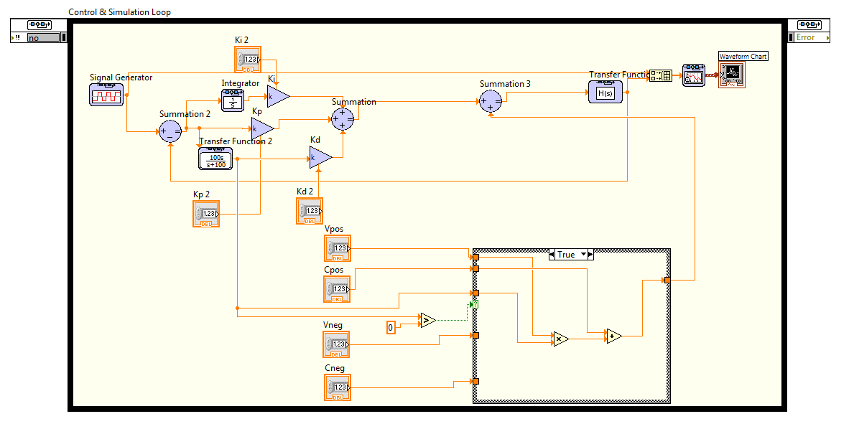
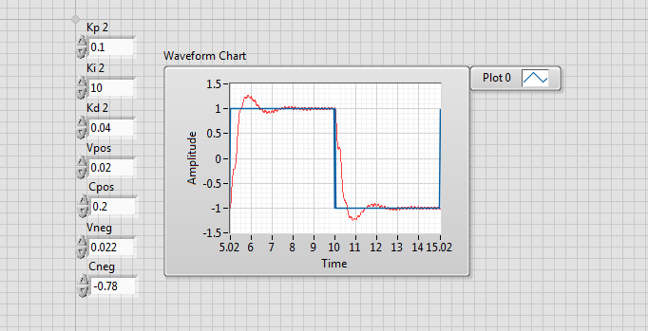

Exercise 2
Now, change the Friction Compensation part of the VI into a SubVI. See the following tutorial to help you create this SubVI from the blocks already in your simulation: https://www.youtube.com/watch?v=zr2qqv1F4kk
Make a simple icon for your VI and connect the inputs and outputs to the pattern shown in the picture below. There is also another picture below of the simulation with the SubVI.
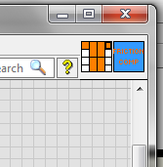
Picture of Icon and Pattern to use
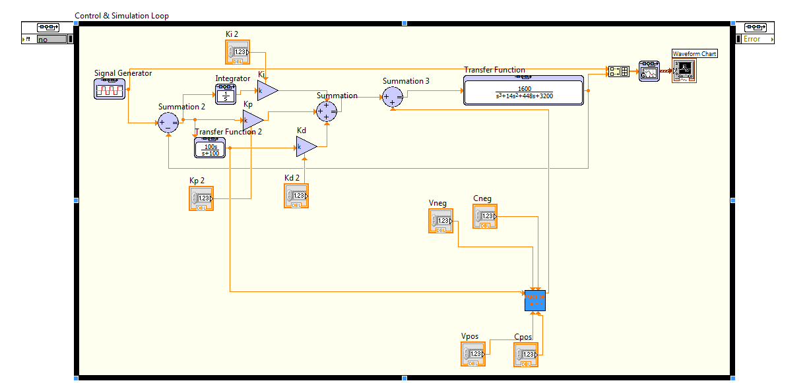
Picture with SubVI

Exercise 3
Now either create a new VI or copy the Simulation Loop and all its contents and run two simulation loops in one VI.
Here in this new VI or new simulation loop, everything is the same except I would like you to replace the SubVI with a Formula Node. A Formula Node allows you to add small amounts of C-code to your LabVIEW program.
To add a variable to a formula node right click on an edge of the formula node and select “Add Input.” To add an output for the formula, right click on an edge and select “Add Output.”

