ME 461 LabVIEW #3
Due October 20th 2:00 PM

Introduction
Simply demonstrate your programs working and be prepared to show me how you built parts of your LabVIEW program. Grading for this assignment is simply full credit if you did the assignment and no credit if you did not complete the assignment. Make sure to ask your instructors questions if you get stuck.

Exercise 1
I would like you to go through the “Basics of Control Design and Simulation” tutorial. It can be found at http://coecsl.ece.illinois.edu/me461/labs/NI-Tutorial-BasicsofCDS.pdf . When you are done with this tutorial you will have saved three files: “My Controls Example VI.vi”, “My Controls Example With Math Script VI.vi” and “My Control and Simulation Example VI.vi” Demo all three of these Vis working for the first part of your check off.
The last VI you build, “My Control and Simulation Example VI.vi”, uses the Control and Simulation Loop. You should be familiar with MathWorks Simulink from previous classes like ME340 and ME360. You can think of the blocks you place inside the Control and Simulation Loop the same as blocks in a Simulink simulation.

Exercise 2
For this next exercise I would like you to reproduce the VI shown in the pictures below. Start out by creating a LabVIEW Project. Inside this project, add a single VI. The reason I want you to use a project is that I would like you to try out using a “shared variable” and these are created in a separate .lvlib file that will also become part of your project. I will give some pointers and instructions below, but they will not be necessarily in the exact order you need to perform the steps or completed steps. In other words, you may need to do a bit of your own hunting to find the necessary blocks and other parts of the program and use LabVIEW help to figure out how to use/wire certain blocks. Many of the blocks I used below come from the “Control Design & Simulation → Simulation” section of LabVIEW

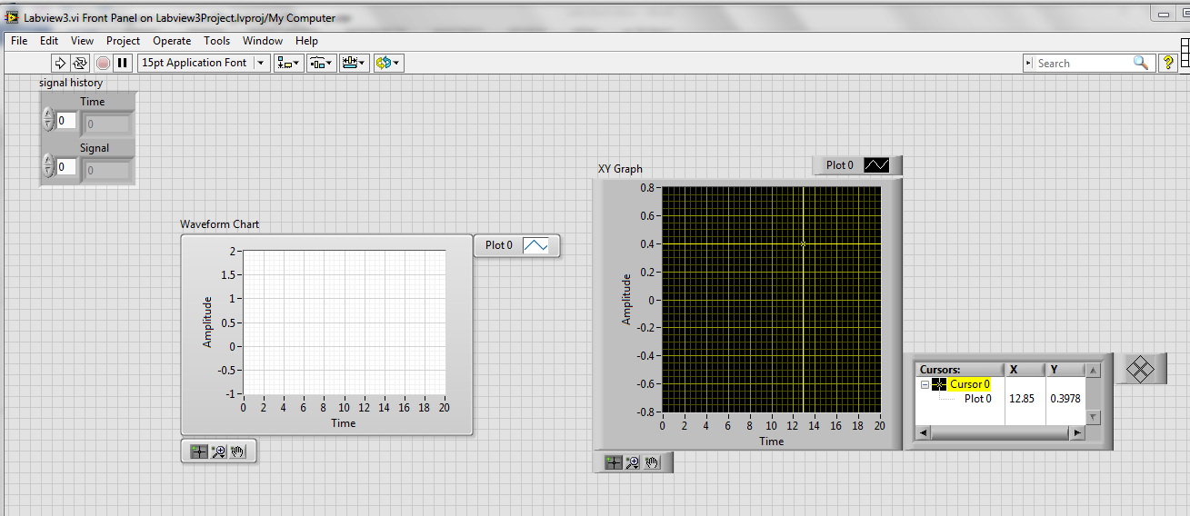

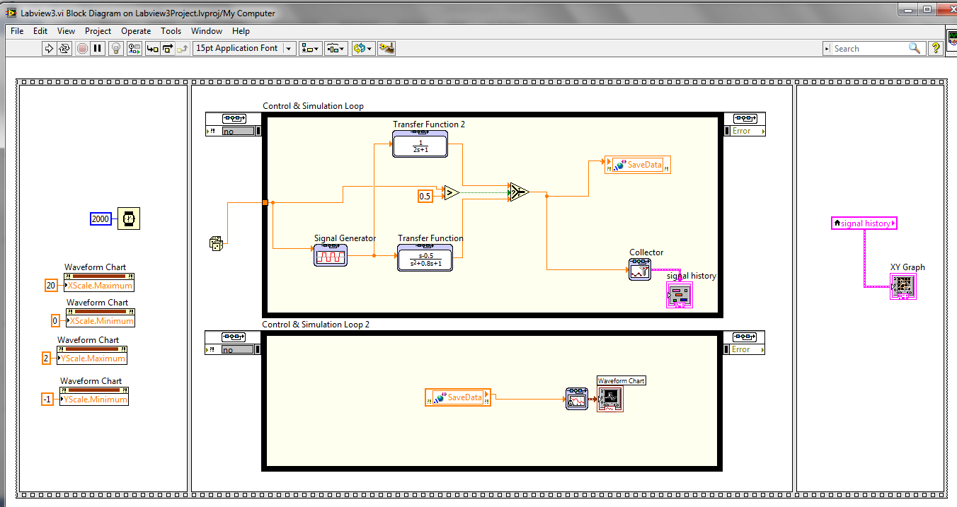

Pointers/Instructions
- Why am I using two Control and Simulation Loops? I am splitting the simulation into two parts. One to run the simulation and the second to plot the data. When you start using the simulation loop on the “MyRIO” development board you will find that to achieve consistent sample periods you will need to divide processing between the two processor cores of the MyRIO. So, to prepare you for this I’m showing you here how we are going to plot data. The simulation’s “y” output is stored into a “Shared Variable” that has a Real-Time FIFO enabled. In the block diagram view below it is the orange “SaveData” blocks. We will set up one of the simulation loops to run on one processor core and the other simulation loop to run on another processor core.
- After you add the two simulation loops, double click on their parameters tab in their top left corner which will bring up the Configure Simulation Parameters window. Set it up as in the pictures below. For the second Simulation Loop, set it up as the same except for the Processor Assignment. Set the processor as “1”.
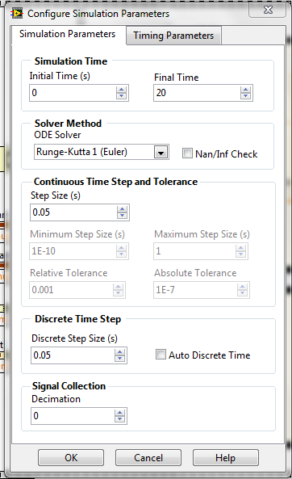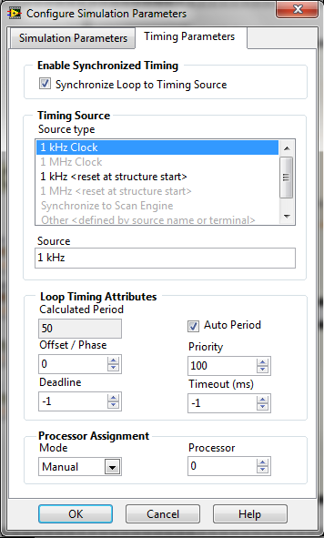

- In your project window, right click on the “My Computer” under your project name and select New → Variable. Give the variable a name. Make the variable type “Single Process” and data type “Double”. Click on the RT FIFO item and check the item “Enable RT FIFO”. The shared variable is stored in a library .lvlib file. Save this library file with a name of your choosing.
- To add the shared variables to your application, simply drag the shared variable from the project window into your block diagram window. Then in your Block Diagram, right click on the shared variable and select the appropriate “Access Mode.”
- Block Locations:
  - Use the Flat Sequence to order when items of your program run. Programming → Structures.
  - Transfer Function: Control Design & Simulation → Simulation → Continuous The transfer function inside the block can be whatever you choose.
  - Signal Generator: Control & Simulation → Simulation → Signal Generation
  - Notice that I set up the Signal Generator to have a terminal input. I want the Amplitude of the Signal Generator to change each run by using the random number generator. If you double click on the signal generator and select the amplitude parameter you can change its parameter source to “terminal.”
  - Collector: Control & Simulation → Simulation → Utilities. The collector is optimized for the simulation loop and is used to collect data for plotting later or even offline. To create the Collector’s output variable that I called “signal history”, hover your mouse just to the right of the Collector and right click. Select Create →Indicator.
  - The Waveform Chart and its accompanying block to its left is called a “SimTime Waveform”. Find it under Control & Simulation → Simulation → Graph Utilities.
  - Select and Greater: Programming → Comparison. I am showing you the Select block so you can see how to choose between two signals and only route one of them to a desired block.
  - Dice (Random Number): Programming → Numeric.
  - Local Variable: Programming → Structures.
  - To add the XY Graph to your program you must switch to the Front Panel window. From there right click and find the XY Graph in Modern → Graph.
  - Property Nodes XScale.Minimum, XScale.Maximum, YScale.Minimum, YScale.Maximum. Property Nodes allow you to change properties of a front panel object (in this case a graph) during your program run. Here I am just setting the range of the X and Y scales. You will see there are a huge number of properties you can change on the fly if you wish. Since there are so many it is hard sometimes to find the correct property to change the item you are interested in. Using Help and trial and error is the way to finally figure out which property to change. Create these property nodes by right clicking on the Waveform Chart block and selecting Create → Property Node → XScale → Range → Minimum. Do the same for X Max, Y Min, and Y Max. If you right click on the Property Node the top option allows you to change the property to a “Write”. (Or “Read” if you need to switch back.)
- In the Front Panel window, right click on both of the graph objectives and turn on their different “Visible Items”. The “Graph Palette” allows you to zoom in and out the graph’s data. The “Cursors Legend” is only available in the XY Graph and it creates a cross hair cursor. After you run your program, play around with both the zooming capability and the cursors.
To save your collected data to a file, to load into Excel or MATLAB, you simply right click on the plot and select Export. This allows you to export directly to an Excel file or you can have it copy the data to the clipboard and then you can pull up your favorite editor (I like Notepad++) and paste all the data into that file. Play around with this export feature and make sure you can pull data into Excel or your favorite editor.

